Partial / residual correlation: EURUSD and USDCHF
Method 07 / daily log returns / leave-currency-out USD factor / Alpari D1 full available history

Study setup
Logical pair: EURUSD , USDCHF
Broker symbols: EURUSD_i , USDCHF_i
Snapshot: 2026-11-03_majors_alpari_D1
Timeframe: D1
Matched return window: 1999-01-05 to 2026-11-02 (UTC bar dates)
Matched return count n: 7148
Dropped unfinished last bar dated 2026-11-03 UTC after a tick-volume check against the prior complete day.
USD-strength sign rule: minus log return when USD is the quote (EURUSD, GBPUSD, AUDUSD, NZDUSD); plus log return when USD is the base (USDJPY, USDCHF, USDCAD). EURGBP is never a constituent.
Control z constituents (5): GBPUSD, AUDUSD, NZDUSD, USDJPY, USDCAD
z_t = equal-weight mean of those USD-strength returns on the same day
Complete matched rows (Excel): EURUSD-USDCHF_Partial_D1.xlsx
Complete matched rows (HTML table): EURUSD-USDCHF_Partial_D1_data.html

Method carried forward
Partial / residual correlation regresses each matched daily log return of close, ln(close_t / close_t-1), on the same leave-currency-out USD strength factor z, then takes Pearson correlation of the two residual series. Quotes are not inverted. z is the equal-weight mean of USD-strength returns from other majors that do not share a non-USD currency with either leg; EURGBP is never a constituent. USD-strength is minus the log return when USD is the quote (EURUSD, GBPUSD, AUDUSD, NZDUSD) and plus the log return when USD is the base (USDJPY, USDCHF, USDCAD). OLS uses an intercept on each leg. rho_partial is symmetric under swap of the two symbols. It describes leftover linear co-movement after removing linear z; it is not a cause, not a lead, and not a trading signal. Daily rows are not independent and residuals are estimated, so the two-sided p-value and Fisher interval are secondary. Same-sample raw Pearson r is a side check only.

Regression on z
leg | intercept_a_or_c | slope_b_or_d | R2
EURUSD | -5.4e-07 | -0.84291535 | 0.47253139
USDCHF | -7.088e-05 | 0.74570252 | 0.28627642

Results
rho_partial: -0.619787
Two-sided p-value: 0
Approximate 95% Fisher interval: [-0.633862, -0.605301]
Same-sample raw Pearson r: -0.748079
rho_partial minus r: 0.128292

Conclusion
Over 7148 matched daily rows for EURUSD and USDCHF after removing a leave-currency-out USD factor built from 5 constituents, rho_partial is -0.6198 (negative, moderate residual linear link in this sample). Approximate 95% Fisher interval: [-0.6339, -0.6053]. Same-sample raw Pearson r is -0.7481 (partial minus r = 0.1283). Leg R-squared on z: EURUSD=0.4725, USDCHF=0.2863. Two-sided p under the usual independent-pairs model is 0; residuals are estimated and daily FX rows are linked, so treat p as secondary. This does not establish cause, lead-lag, or a lasting trading rule.

Charts
Daily closes
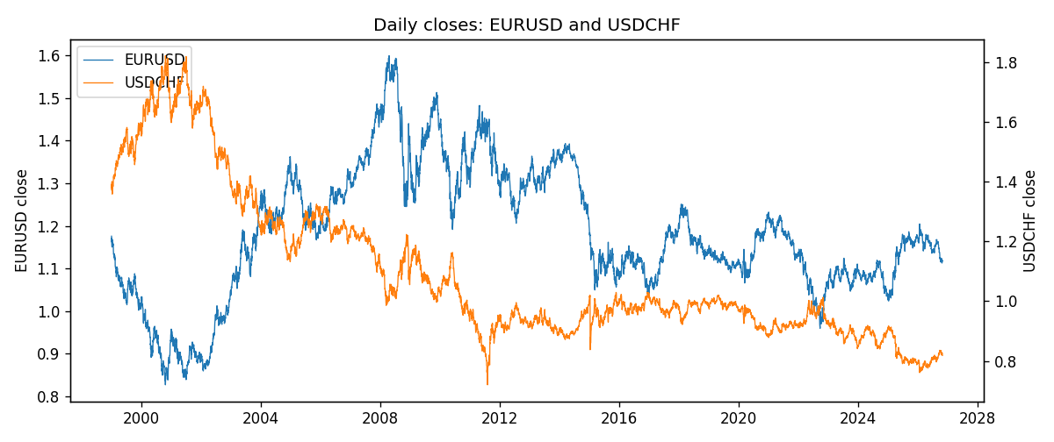
Log returns and control z
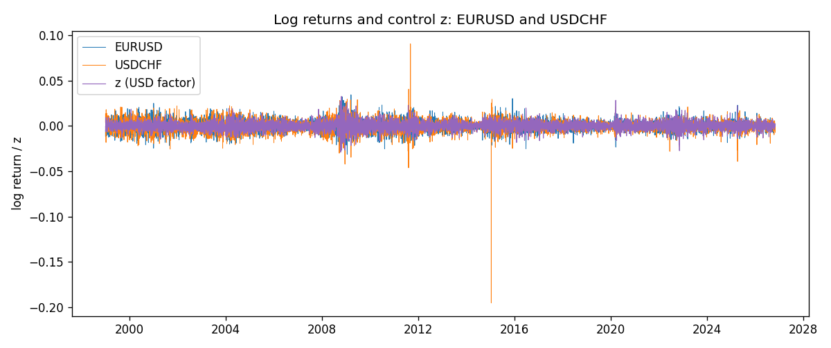
Residual scatter e_x vs e_y
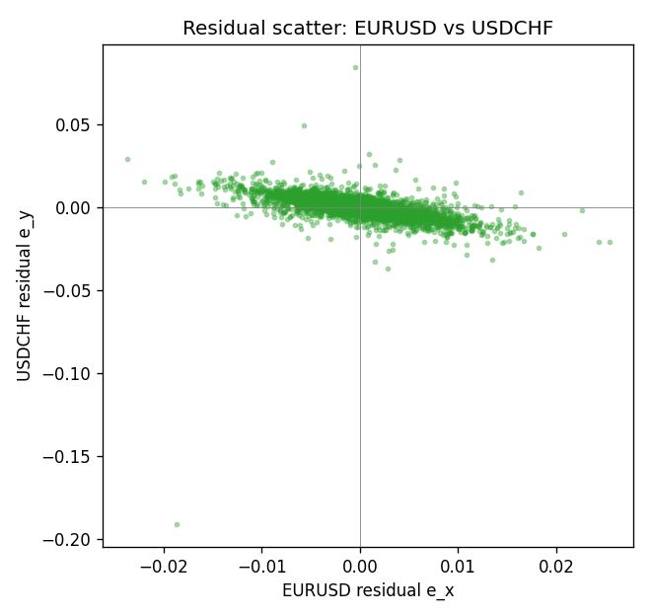

Data report
Every matched row that entered the partial correlation is stored in the sibling Excel workbook named EURUSD-USDCHF_Partial_D1.xlsx. That file is the complete data archive for redrawing charts. Embedding all rows as a Word table is impractical at this length; the Word file holds the column list, column summaries, and the first and last 15 matched rows.
Columns: time, EURUSD_open, USDCHF_open, EURUSD_high, USDCHF_high, EURUSD_low, USDCHF_low, EURUSD_close, USDCHF_close, EURUSD_tick_volume, USDCHF_tick_volume, EURUSD_spread, USDCHF_spread, EURUSD_real_volume, USDCHF_real_volume, EURUSD_log_return, USDCHF_log_return, usd_strength_GBPUSD, usd_strength_AUDUSD, usd_strength_NZDUSD, usd_strength_USDJPY, usd_strength_USDCAD, z, EURUSD_fitted, USDCHF_fitted, EURUSD_resid, USDCHF_resid
Column summaries (matched calculation rows)
column | count | mean | std | min | 25% | 50% | 75% | max
EURUSD_open | 7148 | 1.1816879 | 0.15074041 | 0.8272 | 1.0863875 | 1.16609 | 1.2942 | 1.5995
USDCHF_open | 7148 | 1.0960885 | 0.25173228 | 0.72022 | 0.9203525 | 0.9894 | 1.2355 | 1.8219
EURUSD_high | 7148 | 1.1868219 | 0.15134312 | 0.8326 | 1.0904675 | 1.17121 | 1.29957 | 1.6038
USDCHF_high | 7148 | 1.101368 | 0.25346299 | 0.73305 | 0.9245 | 0.993025 | 1.240225 | 1.8313
EURUSD_low | 7148 | 1.1766784 | 0.15005373 | 0.8227 | 1.0822025 | 1.162475 | 1.2886225 | 1.5865
USDCHF_low | 7148 | 1.0909798 | 0.25015306 | 0.08565 | 0.9169075 | 0.98582 | 1.229425 | 1.8121
EURUSD_close | 7148 | 1.1817317 | 0.15070664 | 0.8267 | 1.0862225 | 1.16602 | 1.2942 | 1.5997
USDCHF_close | 7148 | 1.0960817 | 0.25162815 | 0.72025 | 0.92048 | 0.989445 | 1.2352 | 1.8217
EURUSD_tick_volume | 7148 | 103711.54 | 173856.26 | 469 | 9484.75 | 52998 | 99801.75 | 1471626
USDCHF_tick_volume | 7148 | 74666.538 | 113693.11 | 350 | 12884 | 40421 | 70666.5 | 858589
EURUSD_spread | 7148 | 19.246223 | 16.509774 | 0 | 8 | 12 | 20 | 50
USDCHF_spread | 7148 | 25.894096 | 24.64185 | 0 | 5 | 16 | 50 | 100
EURUSD_real_volume | 7148 | 4.0536992e+10 | 1.6733469e+11 | 0 | 0 | 0 | 0 | 3.6149665e+12
USDCHF_real_volume | 7148 | 2.3408849e+10 | 8.9348471e+10 | 0 | 0 | 0 | 0 | 1.9331921e+12
EURUSD_log_return | 7148 | -2.16e-06 | 0.0058013 | -0.03123819 | -0.00324218 | 0 | 0.00325609 | 0.03433183
USDCHF_log_return | 7148 | -6.945e-05 | 0.0065937 | -0.19545699 | -0.00334697 | 8.15e-05 | 0.00331954 | 0.09051364
usd_strength_GBPUSD | 7148 | 1.992e-05 | 0.00564699 | -0.03112653 | -0.00318167 | -3.426e-05 | 0.0031217 | 0.08388241
usd_strength_AUDUSD | 7148 | -3.157e-05 | 0.00755018 | -0.0806166 | -0.00415111 | -0.00029168 | 0.00385014 | 0.08602525
usd_strength_NZDUSD | 7148 | -1.914e-05 | 0.00764519 | -0.05966839 | -0.004586 | -0.00023666 | 0.00424201 | 0.07027433
usd_strength_USDJPY | 7148 | 5.267e-05 | 0.00620906 | -0.03908203 | -0.00319392 | 0.00012736 | 0.00340928 | 0.05184024
usd_strength_USDCAD | 7148 | -1.226e-05 | 0.00514518 | -0.03859748 | -0.00283513 | 4.873e-05 | 0.00272781 | 0.03436319
z | 7148 | 1.92e-06 | 0.00473104 | -0.02891342 | -0.002771 | -5.263e-05 | 0.00268613 | 0.03253567
EURUSD_fitted | 7148 | -2.16e-06 | 0.00398786 | -0.02742536 | -0.00226472 | 4.382e-05 | 0.00233518 | 0.02437102
USDCHF_fitted | 7148 | -6.945e-05 | 0.00352795 | -0.02163169 | -0.00213723 | -0.00011013 | 0.00193217 | 0.02419105
EURUSD_resid | 7148 | -0 | 0.00421331 | -0.02373101 | -0.00230392 | 3.03e-06 | 0.00226688 | 0.02537671
USDCHF_resid | 7148 | -0 | 0.0055705 | -0.19117059 | -0.00259105 | 0.00012913 | 0.00268963 | 0.08477621
First 15 matched rows (selected columns)
time | EURUSD_close | USDCHF_close | EURUSD_log_return | USDCHF_log_return | z | EURUSD_fitted | USDCHF_fitted | EURUSD_resid | USDCHF_resid
1999-01-05 | 1.1758 | 1.3724 | -0.0048360507 | 0.0039424743 | -0.00094995293 | 0.00080018598 | -0.0007792661 | -0.0056362366 | 0.0047217404
1999-01-06 | 1.1623 | 1.3912 | -0.011547966 | 0.013605652 | -0.0012084101 | 0.0010180435 | -0.00097199829 | -0.01256601 | 0.01457765
1999-01-07 | 1.1712 | 1.3782 | 0.0076280636 | -0.0093883841 | -0.0048748014 | 0.004108501 | -0.0037060355 | 0.0035195626 | -0.0056823486
1999-01-08 | 1.1585 | 1.3935 | -0.010902799 | 0.011040268 | -0.00013745671 | 0.00011532045 | -0.00017338563 | -0.01101812 | 0.011213654
1999-01-11 | 1.1503 | 1.4009 | -0.007103287 | 0.0052963193 | -0.0063071746 | 0.0053158704 | -0.0047741598 | -0.012419157 | 0.010070479
1999-01-12 | 1.1555 | 1.3872 | 0.0045103728 | -0.0098275602 | 0.0093681467 | -0.0078970985 | 0.0069149668 | 0.012407471 | -0.016742527
1999-01-13 | 1.1681 | 1.3621 | 0.010845346 | -0.018259701 | 0.0042821465 | -0.0036100309 | 0.0031223236 | 0.014455377 | -0.021382024
1999-01-14 | 1.1681 | 1.3588 | 0 | -0.0024256692 | 0.0015765174 | -0.0013294146 | 0.0011047292 | 0.0013294146 | -0.0035303983
1999-01-15 | 1.1563 | 1.3834 | -0.010153245 | 0.01794228 | -0.00095611309 | 0.00080537847 | -0.00078385974 | -0.010958623 | 0.01872614
1999-01-18 | 1.1605 | 1.379 | 0.0036256946 | -0.0031856384 | 0.00015473082 | -0.0001309689 | 4.4499352e-05 | 0.0037566635 | -0.0032301377
1999-01-19 | 1.1603 | 1.3789 | -0.00017235436 | -7.2518946e-05 | -0.0027660489 | 0.0023310011 | -0.0021335334 | -0.0025033555 | 0.0020610145
1999-01-20 | 1.1566 | 1.3889 | -0.0031939256 | 0.0072259871 | -0.0023554891 | 0.001984934 | -0.0018273779 | -0.0051788596 | 0.009053365
1999-01-21 | 1.1601 | 1.3836 | 0.0030215416 | -0.0038232689 | -0.00076232259 | 0.00064202949 | -0.00063934968 | 0.0023795121 | -0.0031839192
1999-01-22 | 1.1587 | 1.3834 | -0.0012075213 | -0.0001445609 | 0.0060746592 | -0.0051209674 | 0.0044590048 | 0.0039134461 | -0.0046035657
1999-01-25 | 1.1552 | 1.3868 | -0.0030251979 | 0.0024546976 | -4.0139601e-05 | 3.3290364e-05 | -0.00010081601 | -0.0030584882 | 0.0025555137
Last 15 matched rows (selected columns)
time | EURUSD_close | USDCHF_close | EURUSD_log_return | USDCHF_log_return | z | EURUSD_fitted | USDCHF_fitted | EURUSD_resid | USDCHF_resid
2026-10-13 | 1.11965 | 0.83244 | 0.0037402957 | -0.0024955621 | -0.0036819335 | 0.0031030143 | -0.0028165109 | 0.0006372814 | 0.0003209488
2026-10-14 | 1.11545 | 0.83489 | -0.0037582255 | 0.0029388325 | 0.0023521426 | -0.001983201 | 0.0016831148 | -0.0017750245 | 0.0012557176
2026-10-15 | 1.12172 | 0.82676 | 0.0056053107 | -0.0097855323 | -0.0018558005 | 0.0015637388 | -0.0014547589 | 0.0040415719 | -0.0083307734
2026-10-16 | 1.12371 | 0.82377 | 0.0017724895 | -0.0036230826 | -0.0033423828 | 0.0028168018 | -0.0025633071 | -0.0010443124 | -0.0010597755
2026-10-19 | 1.12086 | 0.82677 | -0.0025394633 | 0.0036351779 | -0.00072330589 | 0.00060914171 | -0.00061025483 | -0.003148605 | 0.0042454328
2026-10-20 | 1.12354 | 0.8246 | 0.0023881672 | -0.0026281224 | -0.0037471172 | 0.0031579587 | -0.0028651186 | -0.00076979144 | 0.00023699614
2026-10-21 | 1.12318 | 0.82427 | -0.00032046717 | -0.00040027413 | -0.0018244715 | 0.0015373311 | -0.0014313968 | -0.0018577982 | 0.0010311226
2026-10-22 | 1.12139 | 0.82032 | -0.0015949606 | -0.0048036381 | -0.0013756352 | 0.0011590001 | -0.0010966984 | -0.0027539607 | -0.0037069397
2026-10-23 | 1.11989 | 0.82497 | -0.001338521 | 0.005652514 | -0.0005950994 | 0.0005010745 | -0.00051465093 | -0.0018395955 | 0.0061671649
2026-10-26 | 1.11735 | 0.82649 | -0.0022706559 | 0.0018407959 | 0.0025435447 | -0.0021445368 | 0.0018258439 | -0.00012611913 | 1.4952073e-05
2026-10-27 | 1.11272 | 0.82865 | -0.004152342 | 0.0026100526 | 0.0012529924 | -0.0010567104 | 0.00086347575 | -0.0030956316 | 0.0017465768
2026-10-28 | 1.1152 | 0.82781 | 0.0022262927 | -0.0010142111 | -0.00014701324 | 0.0001233758 | -0.00018051195 | 0.0021029169 | -0.00083369916
2026-10-29 | 1.11772 | 0.82379 | 0.0022571351 | -0.0048680164 | -0.00012266988 | 0.00010285641 | -0.00016235905 | 0.0021542787 | -0.0047056573
2026-10-30 | 1.11644 | 0.82438 | -0.0011458446 | 0.00071594559 | -0.0009280393 | 0.00078171464 | -0.00076292505 | -0.0019275593 | 0.0014788706
2026-11-02 | 1.11881 | 0.81851 | 0.002120569 | -0.0071459744 | 0.0019353423 | -0.0016318736 | 0.0013723058 | 0.0037524426 | -0.0085182802

